Focus on Evangelism
Conference, 2019
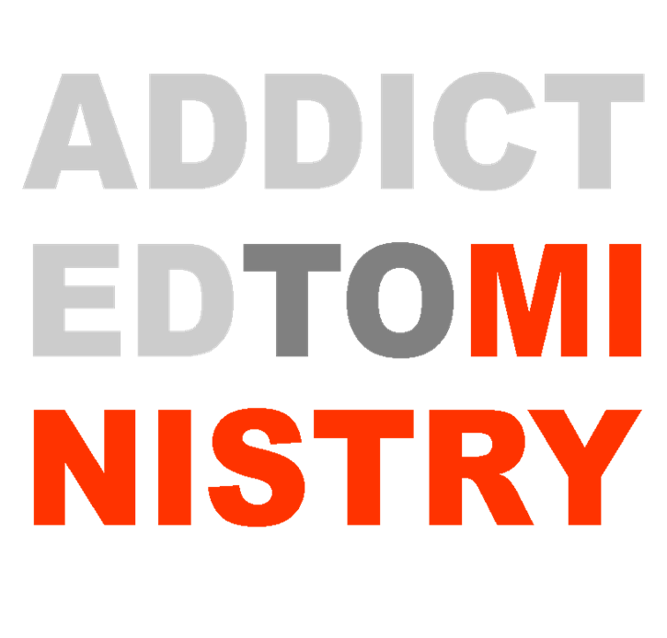

Purpose:
- To train and equip believers for the work of evangelism
- To give an opportunity for Iola Baptist Temple (Iola and KC)
to put this training to practice, teaming up with other like-minded believers
- To promote our KC Mission work

Plan:
- To hold meetings both in Iola and the Kansas City area
- To provide worksheets and materials for everyone
- To supplement the teaching with demonstrations, visuals, motivating singing, etc.
- To video record all lessons and make videos and hand out material available for all.

Procedures:
Wednesday, November 6 (Iola, Fellowship Hall)
- (6:15-6:45) Warm drinks and refreshments
- (7:00-7:10) Welcome and song
- (7:10-7:20) Lesson 1 “Purpose of Organized Soul-winning”
- (7:20-7:30) Lesson 2 “Soul-winning Motivation”
- (7:30-7:40) Lesson 3 “What soul-winning is not”
- (7:40-7:45) (quick break)
- (7:45-7:50) Song
- (7:50-8:20) Lesson 4 “Getting Started (rules and tips)”
- (8:20-8:25) Announcements/Dismissal

Thursday, November 7 (KC)
- (4:30-5:00) Meet at Chick-Fil-A
- (5:00-6:15) Soul-Winning
- (6:30-7:00) Warm drinks and refreshments
- (7:00-7:05) Welcome and song
- (7:05-7:20) (Video clip #1) Lesson 5 “At-the-door etiquette
- (7:20-7:35) (Video clip #2) Lesson 6 “Introducing, Inviting, and Interrogating”
- (7:35-7:40) (quick break)
- (7:40-8:20) (“Video clip #3) Lesson 7 “Presenting the Plan (Delivery)”
- (8:20-8:25) Announcements/Dismissal

Friday, November 8 (Iola)
- (6:15-6:45) Warm drinks and refreshments
- (7:00-7:10) Welcome and song
- (7:10-7:35) (Video clip #3) Lesson 8 “Call to Action (Closing)”
- (7:35-7:45) quick break
- (7:45-7:50) Song
- (7:50-8:10) (Video clip #4) Lesson 9 “Getting Info. for Follow-Up”
- (8:10-8:15) Announcements/Dismissal

Saturday, November 9 (Iola) “Soul-Winning Marathon”
- (11:30-12:30) Lunch
- (12:30-12:45) Job Assignments, charge, and Send off:
- Team 1 (Leader: Pastor)
- Team 2 (Leader: Bro. Steeby)
- Team 3 (Leader: Bro. Justin)
- (1:00-4:30) Soul-Winning
- (4:30-5:00) Meet up/testimonies
- (5:00) Dismissal

Sunday, November 10 (Iola) “Friend Day”
- (9:15) Warm drinks and refreshments
- (9:45-10:40) Sunday School
- (10:50-12:10) Morning service
- Song # “Nothing But the Blood”
- Scripture of the week
- Worship
- Welcome
- Special #1(TBD)
- Song # “I Have Decided to Follow Jesus”
- Announcements
- Offering/instrumental
- Special #2 (TBD)
- Message
- Dismissal
- (12:20-1:30) Lunch

